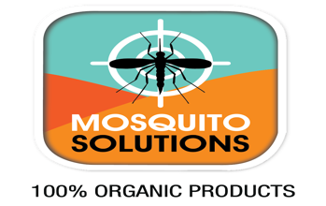 Mosquito Solutions
Pest Control Service Agreement Contract
Company Name: Mosquito Solutions
Address: PO Box 732 Grand Cayman Islands KY1-1303
Phone Number: 1345-548-0720
Email: mosquitosolutions88@gmail.com
Customer Name:

Address: | PO Box: | District
Types of Property to be Sprayed
Residential | Commercial | House Lot | Agriculture
Yes
Length of Service
3 Months | 6 Months | 1 year | One off Service

Description: Full coverage of mosquito barrier to entire exterior of property including all outside structures, vegetation and brush surrounding perimeter with treatment to all stagnant water with weekly sight inspection until infestation is under control.
Special Instructions:
Date of Service:
Expiration Date

Pest to be Control:
Mosquito |  | Ticks |  | Roaches
Others

Special Instructions
Service Guarantee
Mosquito Solutions agree to apply Organic pesticides to control the above name of pest.
Service Renewal
This agreement shall be for an initial period of above choice. In the case of either parties wishes to terminated this agreement, he or she must at least give a month notice before any expiration date.
Company Signature: Date:
Customer Signature: Date:

Bank Information
Name of Bank | Cayman National bank
Payments Information | Mosquito Solutions
Account Number | 01116504

